

Looking Glass Schema

All 39 tables are in Boyce Codd normal form. There are two types, regular and many-to-many.

Many-to-many tables represent many-to-many mappings. Typically the many-to-many tables consist of two columns, together representing a composite key. Each of the two columns is a foreign key or an enum. The same approach is used for one-to-many mappings.

For many-to-one mappings or one-to-one mappings, i.e. functions, these two-column tables are not required because you can simply add attributes to a table to represent such a function.

Not all table attributes are shown in this initial version of the documentation, just the keys, indicating the relationship between tables. For a complete list of attributes for each table, see the table listing in pgAdmin. Attribute descriptions, when not obvious, are also there.

– provides information about algorithms used in processing nodes.

algorithm

Attribute | Type | Primary Key | Foreign Key | References Table
algorithm_id | Int | X

– attributes which appear in tables, in data objects, and flow on data flows.

attribute

Attribute | Type | Primary Key | Foreign Key | References Table
attribute_id | Int | X

– an attribute equivalence set is a set of attributes which refer to the same concept, but may have different names and or types.

attribute_equivalent_set

Attribute | Type | Primary Key | Foreign Key | References Table
attribute_equivalence_id | Int | X

– a many-to-many table marking certain attributes as being part of a specified data exchange standard. Data exchange standards help make systems interoperable. Not all attributes are part of a standard.

attribute_standard

Attribute | Type | Primary Key | Foreign Key | References Table
attribute_id | Int | X | X | attribute
standard_id | Int | X | X | data_ exchange_standard

– a many-to-many table that helps users find attributes that pertain to a particular subject matter. More than one subject may pertain to a particular attribute.

attribute_subject

Attribute | Type | Primary Key | Foreign Key | References Table
attribute_id | Int | X | X | attribute
subject_name | Var char | X | X | subject

– lists the relevant data exchange standards. Data exchange standards are used to make data systems interoperable and to facilitate data exchange between them using controlled vocabularies.

data_exchange_standard

Attribute | Type | Primary Key | Foreign Key | References Table
standard_id | Int | X

– a bundle of attributes, objects, or some combination.

data_object

Attribute | Type | Primary Key | Foreign Key | References Table
data_object_id | Int | X

– a set of data objects that represent the same concept but may contain different attributes.

data_object_equivalence_set

Attribute | Type | Primary Key | Foreign Key | References Table
object_equivalence_id | Int | X

– a many-to-many table marking certain data objects as being part of a specified data exchange standard. Data exchange standards help make systems interoperable. Not all objects are part of a standard.

data_object_standard

Attribute | Type | Primary Key | Foreign Key | References Table
data_object_id | Int | X | X | data_object
standard_id | Int | X | X | data_ exchange_standard

– data which flows between 2 nodes in a datas ystem.

dataflow

Attribute | Type | Primary Key | Foreign Key | References Table
dataflow_id | Int | X

– a many-to-many table providing the mapping between dataflows and the application level protocols used for that flow. Application protocol is one of 5 levels in the standard 5-level network model.

dataflow_application_protocol

Attribute | Type | Primary Key | Foreign Key | References Table
dataflow_id | Int | X | X | dataflow
application_protocol | enum | X |  | NA

– a many-to-many table giving the mapping between data flows and any files that flow on them.

dataflow_file

Attribute | Type | Primary Key | Foreign Key | References Table
dataflow_id | Int | X | X | data_object
file_format | enum | X |  | NA

– a many-to-many table providing the mapping between dataflows and the network level protocols used for that flow. Network protocol is one of 5 levels in the standard 5-level network model.

dataflow_network_protocol

Attribute | Type | Primary Key | Foreign Key | References Table
dataflow_id | Int | X | X | dataflow
network_protocol | enum | X |  | NA

– a many-to-many table providing the mapping between dataflows and the attributes that flow on them. These are distinguished by the term “nonembedded” to indicate that the attribute in question is not part of an object on the same flow.

dataflow_nonembedded_attribute

Attribute | Type | Primary Key | Foreign Key | References Table
dataflow_id | Int | X | X | dataflow
attribute_id | Int | X | X | attribute

– a many-to-many table providing the mapping between dataflows and the data objects that flow on them.

dataflow_object

Attribute | Type | Primary Key | Foreign Key | References Table
dataflow_id | Int | X | X | dataflow
data_object_id | Int | X | X | data_object

– a many-to-many table providing the mapping between dataflows and the transport level protocols used for that flow. Transport protocol is one of 5 levels in the standard 5-level network model.

dataflow_transport_protocol

Attribute | Type | Primary Key | Foreign Key | References Table
dataflow_id | Int | X | X | dataflow
transport_protocol | enum | X |  | NA

– data, such as that found in a database. The dataset and process_node tables are unique in the way that their keys are foreign keys due to the fact that a dataset and a processing node are both types of nodes within a data system, forming a kind of inheritance. Point of contact is also a foreign key.

dataset

Attribute | Type | Primary Key | Foreign Key | References Table
dataflow_id | Int | X | X | node
poc_id | Int |  | X | poc

– a many-to-many table providing the mapping between datasets and their subject matter.

dataset_subject

Attribute | Type | Primary Key | Foreign Key | References Table
node_id | Int | X | X | dataset
subject | Var char | X | X | NA

– a many-to-many table providing the mapping between datasets and the tables that are contained in them. The “ums” prefix is added to avoid conflicts with the SQL reserved word “table.”

dataset_table

Attribute | Type | Primary Key | Foreign Key | References Table
node_id | Int | X | X | dataset
table_id | Var char | X | X | ums_table

– a many-to-many table providing the mapping between enums and valid values that appear in their code lists. This refers to the enums that are used throughout an enterprise’s data systems, not to be confused with enums in the Looking Glass metadata schema. These are in the data, not the metadata. In the Looking Glass metadata schema, all enums are defined using types.

enum_value

This many-to-many table differs fro most in that the parts of the composite key are not foreign keys.

Attribute | Type | Primary Key | Foreign Key | References Table
enum_name | Var char | X |  | NA
enum_value | Var char | X |  | NA

– this is a list of data system nodes. Datasets and processing nodes are both system nodes, so there is an inheritance relationship there. Therefore, the keys for datasets and processing nodes are borrowed from this table.

node

Attribute | Type | Primary Key | Foreign Key | References Table
node_id | Int | X

– a many-to-many table providing the mapping between data objects and attributes that are part of that object.

object_attribute

Attribute | Type | Primary Key | Foreign Key | References Table
data_object_id | Int | X | X | dataset
attribute_id | Int | X | X | attribute

– Certain objects represent the same concept as other objects, though they might have different names or attributes. Collected together, they form an object equivalence set. These can be used as a tool in forming controlled vocabularies and data exchange standards.

object_equivalence_set

Attribute | Type | Primary Key | Foreign Key | References Table
object_equivalence_set_id | Int | X

– a many-to-many table providing the mapping between data objects and the related subject matter. Notice that the many-to-many table construction permits an object to relate to multiple subjects and a subject to be relate to multiple objects, which is often the case.

object_subject

Attribute | Type | Primary Key | Foreign Key | References Table
data_object_id | Int | X | X | data_object
subject_name | Var char | X | X | subject

– On object may contain other objects as well as attributes. This table lists those relations. Note that both foreign keys are from the same table, data_object. Hence, it is a relationship between a table and itself.

parent_child_object

Attribute | Type | Primary Key | Foreign Key | References Table
data_object_id_parent | Int | X | X | data_object
data_object_id_child | Int | X | X | data_object

– This table lists the points of contact. It appears in other tables as a foreign key and allows users to find experts and responsible parties on a number of topics.

poc

Attribute | Type | Primary Key | Foreign Key | References Table
poc_id | Int | X

– Processing node are one of the two node types in a data system. Nodes and processing nodes are related by inheritance. Because of this, the key is both a primary and a foreign key.

processing_node

Attribute | Type | Primary Key | Foreign Key | References Table
node_id | Int | X | X | node

– As you would expect, every processing node executes one or more algorithms.

processing_node_algorithm

Attribute | Type | Primary Key | Foreign Key | References Table
node_id | Int | X | X | processing_node
algorithm_id | Int | X | X | algorithm

– a list of data topics. The reason this is not represented using Postgres Type enums is that this list varies according to the enterprise data systems, rather than being a type within the metadata schema.

subject

Attribute | Type | Primary Key | Foreign Key | References Table
subject_name | Var char | X

– One never knows what word a person will use to describe a subject. This table can be used to make a subject search more flexible. It is one of those strange tables that relates another table to itself.

synonym

Attribute | Type | Primary Key | Foreign Key | References Table
subject_name_a | Var char | X | X | subject
subject_name_b | Var char | X | X | subject

– a list of data systems. A data system is a collection of datasets and processing nodes connected by dataflows.

system

Attribute | Type | Primary Key | Foreign Key | References Table
system_id | int | X

– Every system contains one of more dataset node. Also, a dataset can be part of more than one system. Hence, this table.

system_dataset

Attribute | Type | Primary Key | Foreign Key | References Table
node_id | Int | X | X | dataset
system_id | Int | X | X | system

– Just like system_dataset except for processing nodes. Every system contains one or more processing nodes.

system_processing_node

Attribute | Type | Primary Key | Foreign Key | References Table
node_id | Int | X | X | processing_node
system_id | Int | X | X | system

– Every system covers one or more subjects.

system_subject

Attribute | Type | Primary Key | Foreign Key | References Table
system_id | Int | X | X | system
subject_name | Int | X | X | subject

– Every table contains one or more column headers, otherwise known as attributes.

table_attribute

Attribute | Type | Primary Key | Foreign Key | References Table
table_id | Int | X | X | ums_table
attribute_id | Int | X | X | attribute

– Every table covers one or more subjects.

table_subject

Attribute | Type | Primary Key | Foreign Key | References Table
table_id | Int | X | X | ums_table
subject_name | Int | X | X | subject

– Just as subject names can have synonyms, there are topic and subtopics that form relations within the subject table. Such hierarchies produce tree graphs because a subject may have multiple sub-subjects, which can have sub-sub-subjects etc. The tree graphs can be drawn and visualized from this table. This table can be used for subject searches, just like the synonym table. One never knows what level of specificity a user will start their search at. Whatever level a searcher starts at, the search algorithm could also return all results for subjects higher up in the tree, since those subjects would also apply.

taxonomy

Attribute | Type | Primary Key | Foreign Key | References Table
subject | Var char | X | X | subject
sub_subject | Var char | X | X | subject

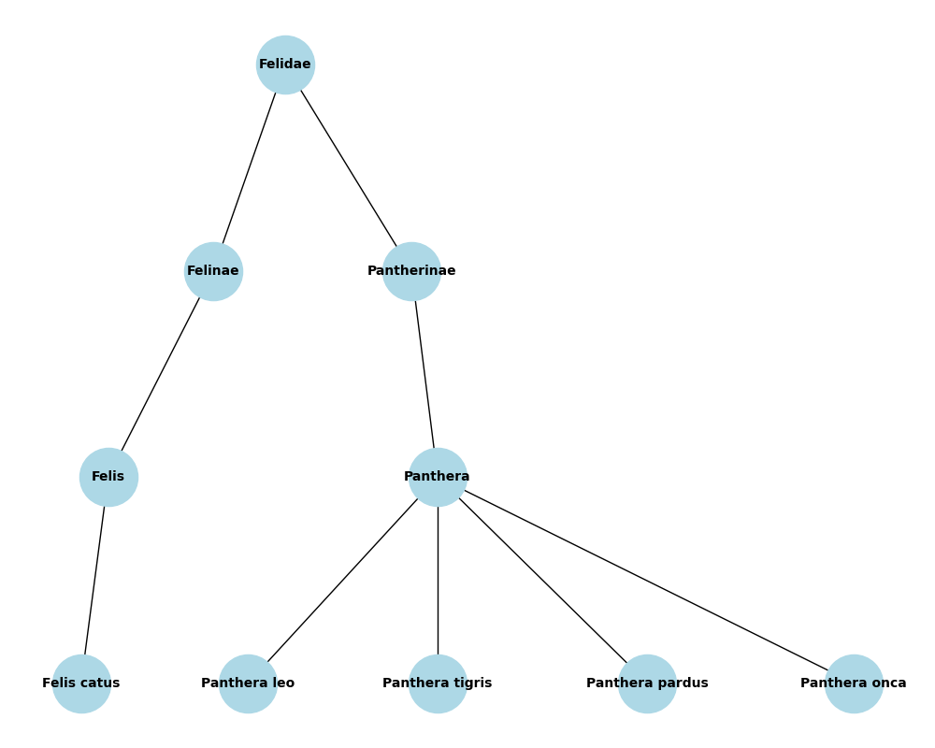
Family, sub-family, genus, and species in the cat taxonomy.

– a list of tables in the enterprise data systems at hand. It’s a table of tables! The ums prefix stands for Universal Metadata Schema to differentiate it from the SQL reserved word “TABLE.”

ums_table

Attribute | Type | Primary Key | Foreign Key | References Table
table_id | int | X

– User groups with particular roles also appear in system data flow diagrams. This table describes them.

user_role
Attribute | Type | Primary Key | Foreign Key | References Table
node_id | int | X | X | node

